Workplace Training Strategies

Child Safety and Wellbeing Policy

Outline

The National Principles for Child Safe Organisations emphasise the importance of each organisation having policies and procedures that document how the organisation is safe for young people. The National Principles also indicate the need for organisations to develop, implement and regularly review and improve their child safe policies and practices.
All students under the age of 18 of age who are supported by WTS have a right to feel and be safe. WTS is committed to the safety and well-being of young individuals accessing our services. WTS undertakes to comply with relevant child safety legislation across jurisdictions of operations and commits to establishing and maintaining child safe environments.

Purpose
The WTS Child Safety and Wellbeing Policy demonstrates our commitment to creating and maintaining a child safe and child-friendly organisation, where children and young people are safe and feel safe.
This policy provides an overview of our approach to implementing Ministerial Order 1359 (PDF, 363KB) which sets out how the Victorian Child Safe Standards apply in school environments.
It informs the WTS team of everyone’s obligations to act safely and appropriately towards young people and children and guides our processes and practices for the safety and wellbeing of students across all areas of our work.

Scope
This policy:
- applies to all WTS staff and trainers who communicate with and or work in direct contact with young people being students.
- applies in all physical and online training environments used by young people our students and is accessed through our enrolment, online training platforms and student handbook.

Definitions
‘Young Person’ or ‘Child/Children’ means for the purpose of this policy a person under the age of 18 years. This also includes those that are deemed to be at a higher risk
• The cultural safety of Aboriginal/Torres Strait Islander children and young people under the age of 18years.
• The cultural safety of children and young people under the age of 18 years from a culturally and/or linguistically diverse background.
• The safety of children and young people under the age of 18 years with a disability.

‘Abuse’ means for the purpose of this policy any act committed against a child involving but not limited to:
• Physical violence
• Sexual offence
• Serious emotional or psychological abuse
• Serious neglect
This policy applies to all WTS Training and Learning activities inclusive of face to face, online and off site environments.

WTS Statement of commitment to child safety
All students under the age of 18 of age who are enrolled and trained by WTS have a right to feel and be safe. WTS is committed to the safety and well-being of young individuals accessing our services. WTS undertakes to comply with relevant child safety legislation across jurisdictions of operations and commits to establishing and maintaining child safe environments:

For all young people enrolled and trained by WTS we commit to ensure:
• all trainers and staff have a Working with Children Check
• all staff participate in an initial child protection induction and receive updates
• all staff are aware of the indicators of abuse – sexual harm, grooming, physical harm, domestic and family violence, emotional harm, neglect
• Ensure all personnel are aware of their obligation to advise Senior Management at WTS of any concerns about the safety, welfare and wellbeing of young people during their training program. All staff of WTS are obligated under the Duty of Care to report any concerns about the safety, welfare and wellbeing of the students.
• Ensure that all personnel are aware of their legal duty of care and obligations under the new criminal offences “Failure to Protect” “Failure to Disclose” and to report suspected abuse and of the procedures for doing so. This is detailed in our Trainer’s Handbook.
• Trainers to be aware of student allocations being young people under 18 years of age. The age of the students are detailed in our Student Management System – Axcelerate, and WTS personnel all have access to this information.
All WTS personnel will complete an online child safe training. WTS provides ongoing support for its staff to ensure the establishment and maintenance of a child safe environment is promoted.
WTS actively encourages all young people, being students, family and carers to provide concerns in the form of verbal and/or written format to WTS’s Senior Management team.

The 11 Standards set out minimum requirements and outline the actions organisations must take to keep children and young people safe.

The Standards provide more clarity for organisations and are more consistent with Standards in the rest of Australia.

The 11 Standards include specific requirements:
- to involve families and communities in organisations’ efforts to keep children and young people safe
- for a greater focus on safety for Aboriginal children and young people
- to manage the risk of child abuse in online environments
- in relation to governance, systems and processes to keep children and young people safe.

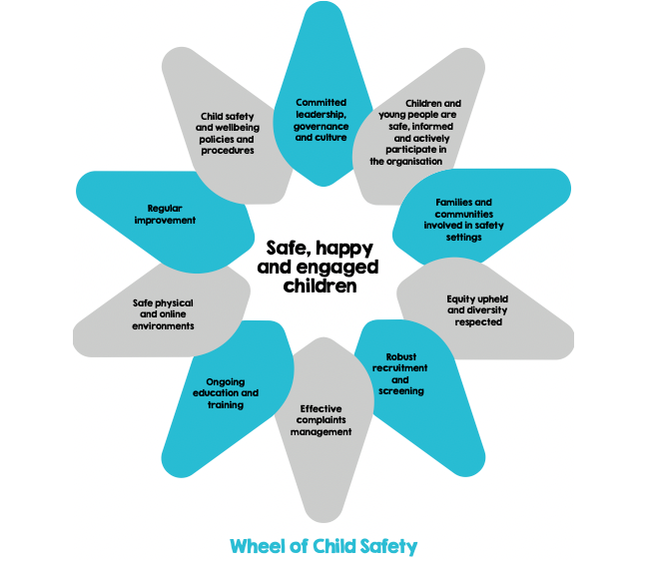

Child Safe Standards
Principal 1

WTS Statement of Commitment, organisation leadership, governance and culture
WTS will facilitate an organisational culture of child safety and the prevention of child abuse occurring within the organisation by:
- Ensuring that staff, young children and families know that they can communicate concerns to our trainers and management for any concern relating to child abuse and that the process is available to all parties
- staff are aware of their responsibilities for identifying possible occasions for child abuse and for establishing controls and procedures for preventing such abuse and/or detecting such abuse. This awareness commences at staff induction and continues as a part or WTS professional development.
- Providing a process and guidance to staff as to the action that should be taken where they suspect any abuse within or outside of the organisation

Principal 2

Young people are informed about their rights, participate in decisions affecting them and are taken seriously.
Young people are informed about their rights and understanding appropriate and inappropriate behaviour and being able to raise concerns if they feel unsafe and ensuring they feel safe to do so.
The importance of friendships is recognised and support from peers is encouraged, to help young people feel safe and be less isolated.
Staff are attuned to signs of harm and facilitate appropriate-friendly ways for young people to express their views, participate in decision-making and raise their concerns
WTS support and are committed to the ‘Speak up and make a complaint’ campaign and to ensure the safety and well-being of its young people being enrolled students.
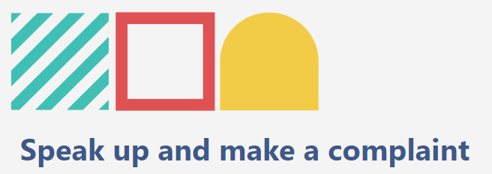
The Royal Commission into Institutional Responses to Child Sexual Abuse found that appropriate complaint handling and response is an essential standard of a child safe institution. The Royal Commission’s research affirmed the importance of institutions taking a child-focused approach to complaint handling. A child-focused approach helps children and young people to feel comfortable and empowered to make a complaint or raise a concern.
Principle 2 of the National Principles for Child Safe Organisations- external site states that children and young people should be:
- informed about their rights
- participate in decisions affecting them, and
- be taken seriously.
This applies across all areas where organisations engage with children and young people, including when children and young people raise complaints and concerns. Children and young people are more likely to speak up about concerns if they know their views are valued and welcomed.
Raising complaints in an organisation is difficult – the process can be complex and emotionally draining. This is particularly true for children and young people. Children and young people may be unaware they have the right to speak up when they feel uncomfortable or unsafe, and can find the complaint process scary and confusing.

Principal 3

Families and communities are informed and involved in promoting child safety and wellbeing.
WTS welcomes and invites family and community to meet with WTS representatives to discuss in consultation with the young person the most suitable program offerings.
Families and communities are welcomed into a friendly environment, inclusive of all cultures. WTS uses a variety of communication methods and provides information on programs and support, through a number of mediums, like email, websites and meetings.
Parents, family members, caregivers and the community are informed about the organisation’s operations and governance.

Principal 4

Equity is upheld and diverse needs respected in policy and practice.
WTS builds an organisational culture that acknowledges the strengths and individual characteristics of children, and embraces all children regardless of their abilities, sex, gender, or social, economic or cultural background.
- WTS is welcoming of all young people and recognise a young person’s backgrounds and circumstances
- We understand ALL young people’s diverse circumstances and provide support and responds to those who are vulnerable.
- Young people have access to information, support and complaints processes in ways that are culturally safe, accessible and easy to understand.

Principal 5

WTS staff working with young people are suitable and supported to reflect child safety and wellbeing values in practice.
- Staff are screened and must hold a Working with Children Check
- All staff receive induction and are aware of their responsibilities to young people, including escalation to management, information sharing and reporting obligations.
- Child safety and wellbeing professional develop is available

Principal 6

WTS have processes to respond to complaints and concerns of young people
- We have a complaint handling policy which outlines reporting obligations
- Our compliant handling processes is outlined in our enrolment process to ensure the understanding of young people and family, community if required
- Complaints are taken seriously and responded to promptly and thoroughly.
- We have policies and procedures in place that address reporting of complaints and concerns to relevant authorities, whether or not the law requires reporting, and co-operates with law enforcement.
- Reporting and privacy are met.

Principal 7

Staff are equipped with the knowledge, skills and awareness to keep young people safe through ongoing education and training.
- To effectively implement the organisation’s child safety and wellbeing policy to ensure the safe environment for young people
- To recognise indicators of child harm including harm caused by other children and young people.
- To respond effectively to issues of young person's safety and wellbeing
- To build a culturally safe environment for young people

Principal 8

Physical and online environments promote safety and wellbeing while minimising the opportunity for young people to be harmed.
- We identify and mitigate risks in the online and physical environments without compromising a young person's right to privacy, access to information, social connections and learning opportunities.
- Our online environment is used in accordance with the organisation’s Code of Conduct and child safety and wellbeing policy and practices.
- Risk management plan/checklist to consider risks posed by organisational settings, activities, and the physical environment.

Principal 9

Implementation of the national child safe principles is regularly reviewed and improved.
- We review, evaluate and improve child safe practices as a part of our continuous improvement
- Complaints, concerns and safety incidents are analysed to identify causes and systemic failures so as to inform continuous improvement.
- The organisation reports on the findings of relevant reviews to staff community and families and young people.

Principal 10

Policies and procedures document how the organisation is safe for children and young people.
- Policies and procedures address all national child safe principles.
- Policies and procedures are documented and easy to understand.
- Best practice models and stakeholder consultation informs the development of policies and procedures.
- Management support compliance with policies and procedures.
- Staff understand and implement policies and procedures.

WTS Code of Conduct

Acceptable behaviours
As WTS staff, volunteers, contractors, and any other member of our community involved in child-connected work, we are responsible for supporting and promoting the safety of children by:
- upholding our WTS commitment to child safety at all times and adhering to our Child Safety and Wellbeing Policy
- treating students and families in our school community with respect in our school environment and outside our school environment as part of normal social and community activities
- listening and responding to the views and concerns of students, particularly if they disclose that they or another child or student has been abused or are worried about their safety or the safety of another child or student
- promoting the cultural safety, participation and empowerment of Aboriginal students, students with culturally and/or linguistically diverse backgrounds, students with a disability, international students, students who are unable to live at home and lesbian, gay, bisexual, transgender and intersex (LQBTIQ+) students
- ensuring, as far as practicable, that adults are not alone with a student – one-to-one interactions between an adult and a student are to be in an open space or in line of sight of another adult.
- reporting any allegations of child abuse or other child safety concerns to management and relevant authorities
- understanding and complying with all reporting and disclosure obligations (including mandatory reporting) in line with our child safety responding and reporting and procedures detailed in this policy
- if child abuse is suspected, ensuring as quickly as possible that the student(s) are safe and protected from harm.

Unacceptable behaviours
As WTS staff, volunteers, contractors and member of our community involved in child-connected work we must not:
- ignore or disregard any concerns, suspicions or disclosures of child abuse or harm
- develop a relationship with any student that could be seen as favouritism or amount to ‘grooming’ behaviour (for example, by offering gifts)
- display behaviours or engage with students in ways that are not justified by the educational or professional context
- ignore an adult’s overly familiar or inappropriate behaviour towards a student
- discuss intimate topics or use sexualised language, except when needed to deliver the school curriculum or professional guidance
- treat a child or student unfavourably because of their disability, age, gender, race, culture, vulnerability, sexuality or ethnicity
- communicate directly with a student through personal or private contact channels (including by social media, email, instant messaging, texting etc) except where that communication is reasonable in all the circumstances, related to schoolwork or extra-curricular activities or where there is a safety concern or other urgent matter
- photograph or video a child or student in a school environment except in accordance with our photography and marketing consensus where required for duty of care purposes
- consume alcohol against school policy or take illicit drugs in the school environment or at school events where students are present
- have contact with any student outside of school hours except when needed to deliver the school curriculum or professional guidance and parental permission has been sought.

Breaches to the Child Safety Code of Conduct
All WTS staff, volunteers, contractors and any other member of the community involved in child-connected work who breach this Child Safety Code of Conduct may be subject to disciplinary procedures in accordance with their employment agreement or relevant industrial instrument, professional code or terms of engagement.
In instances where a reportable allegation has been made, the matter will be managed in accordance with the Department of Education and Training or other governing authority, and may be subject to referral to Victoria Police.
All breaches and suspected breaches of the WTS Child Safety Code of Conduct must be reported to the CEO.

A step-by-step guide to making a report to Child Protection or Child FIRST
Protective concerns
You are concerned about a child because you have:
- Received a disclosure from a child about abuse or neglect
- Observed indicators of abuse or neglect
- Been made aware of possible harm via your involvement in the community external to your professional role

At all times remember:
- Record your observations
- Follow appropriate protocols
- Consult notes and records
- Consult with appropriate colleagues if necessary
- Consult with other support agencies if necessary

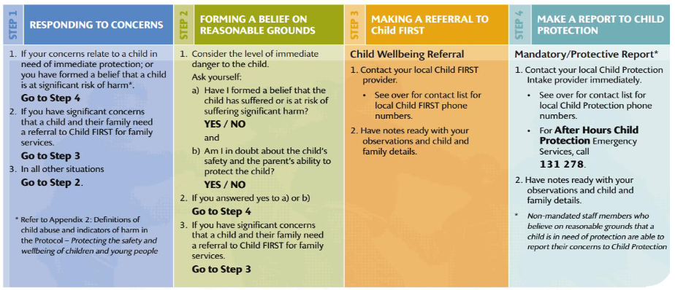

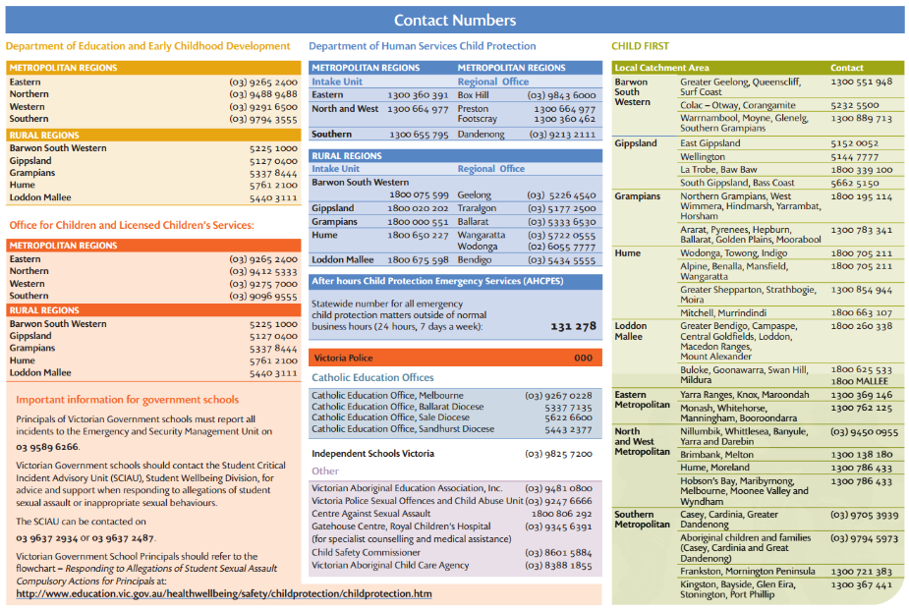
Reporting to the Victorian Commission for Children and Young People
In addition, in Victoria the Reportable Conduct Scheme requires the CEO to notify a ‘reportable allegation’ to the Commission for Children and Young People regardless of how long ago the alleged conduct occurred.

Initial notification is required within 3 days of becoming aware of reportable conduct, followed by detailed reporting within 30 days and a final report on the conclusion of the allegations being investigated. A ‘reportable allegation’ is a reasonable belief that there has been:
- a sexual offence, sexual misconduct or physical violence committee against, with or in the presence of a child under 18 years;
- behaviour causing significant emotional or psychological harm to a child under 18 years; or
- significant neglect of a child under 18 years, or misconduct involving any of the above, whether or not the person the allegations relate to provides services to children, and even if the allegations arises outside the person’s employment.

Full and accurate records relating to incidents of inappropriate behaviour or allegations of child abuse and any subsequent investigations must be kept and retained for at least 45 years. Records must be clear, objective and thorough, be created as close as possible to the time an incident occurred and show the author and date created.

Reporting allegations of historical child abuse to the Victorian Commission for Children and Young People
From 1st July 2017, an obligation exists in Victoria for allegations of child abuse that are either made or remade (repeated) after that date, to be reported by WAI to the Victorian Commission for Children and Young People. Note that allegations made prior to 1st July 2017 are not captured by the reporting requirement.

In relation to allegations of historical child abuse, an allegation is considered to be made when either
- the allegation is conveyed or communicated to another person or organisation, or
- the head of an organisation forms a reasonable belief that reportable conduct or misconduct that may involve reportable conduct has occurred, including by having personally witnessed relevant conduct.

Allegations remade after 1st July 2017 may need to be reported to the Commission even if the allegation concerns the same or substantially the same conduct as was alleged before the reporting requirement commenced. If the organisation is satisfied that the matter has already been properly investigated and findings made, these may be submitted to the Commission. However, if new evidence comes to light, the organisation should seek advice from the Commission about the need for a fresh investigation.

The reporting obligations do not exist in relation to workers whose employment ceased prior to 1st July 2017. However in relation to employment after that date, reporting is required even if the person has resigned or been dismissed.

Confidentiality
Information related to allegations of child abuse must be handled sensitively and with due regard to confidentiality and fairness to all parties. Records must be kept in a secure location and information is to be shared on a ‘need to know basis’ only.

The requirement for confidentiality does not outweigh the need to protect the child and should therefore not prevent action being taken in relation to actual or suspected child abuse.

Responsibilities
Staff will
• Ensure they are aware of and follow the mandatory reporting requirements for child abuse for the state in which they work.

Managers will
• Ensure compliance with child abuse reporting requirements.
• Coordinate the reporting process (Steps 1 to 5 below) when they become aware of an incidence of child abuse or a reasonable belief or suspicion of child abuse, and keep the relevant Executive Member/CEO informed of progress.
• Take in-house action to ensure appropriate staff or student conduct in relation to children. This includes investigating and acting on inappropriate conduct.
• Take action in relation to any risks to child safety in the Institute’s operations that they become aware of including as a result of a complaint.
• Ensure full and accurate records relating to incidents of inappropriate behaviour or allegations of child abuse and any subsequent investigations must be kept and retained in accordance with Institute procedures.

The CEO will
• Ensure reporting to the Victorian Commission for Children and Young People is completed as appropriate.

Reporting incidents, disclosures and suspicions of child abuse
The following are reporting requirements in priority order to follow when a staff member receives a disclosure of child abuse, develops a suspicion or reasonable belief that child abuse is occurring or becomes aware of an incidence of child abuse:

Step 1
If a child is at immediate risk of harm, immediate action must be taken to ensure their safety by
a. Separating the alleged victims and others involved
b. Administering first aid where required
c. Calling 000 for urgent medical and/or police assistance
d. Notifying the relevant department manager for future liaison with Police
e. Maintaining the integrity of the potential crime scene and preserve evidence, where applicable.
If the child is not at immediate risk of harm proceed to Step 2.

Step 2
Make a report to the relevant child protection authority in line with mandatory reporting requirements and management team within WTS.

The WTS management team will offer support (where applicable) and liaise with authorities as appropriate. The WTS management team will also notify the relevant Executive Member and keep them informed of progress.

Support may be sourced via WTS, the AASN Mentoring Program or a person of the individual’s choice. The WTS management team will ensure WTS fulfils its obligation to notify the Victorian Commission for Children and Young People, where appropriate.

Step 3
Following consultation with the relevant Child Protection Agency or Police about

• the appropriateness of contact (e.g. if the parent/carer is alleged to be engaged in abuse) and
• what information can be shared,

the relevant manager will contact the child’s parent or carer, where advised by the authorities that this is appropriate.

Step 4
Maintain records of the report and follow up action using the WTS ‘Child Safe Register; including any supporting information, and store in a secure location on their student file.

Full and accurate records relating to incidents of inappropriate behaviour or allegations of child abuse and any subsequent investigations must be kept and retained for at least 45 years. Records must be clear, objective and thorough, be created as close as possible to the time an incident occurred and show the author and date created.

Step 5
The relevant manager will put appropriate ongoing support in place for the child for their ongoing safety and welfare. This may include developing a safety plan for the child and referral to wellbeing professionals.
Where appropriate, the relevant management personnel will initiate an in-house investigation and/or take appropriate action in relation to:
• Any inappropriate staff or student conduct that may have been identified as a result of the case;
• Note that in-house investigations of individual behaviour should not occur when investigations by external authorities are being undertaken so as not to compromise those investigations.
• Any risks to child safety in the Institute’s operations that have arisen as a result of the case.
• Undertaking appropriate reporting to the Victorian Commission for Children and Young People on the progress and completion of any investigation.

Escalation Register
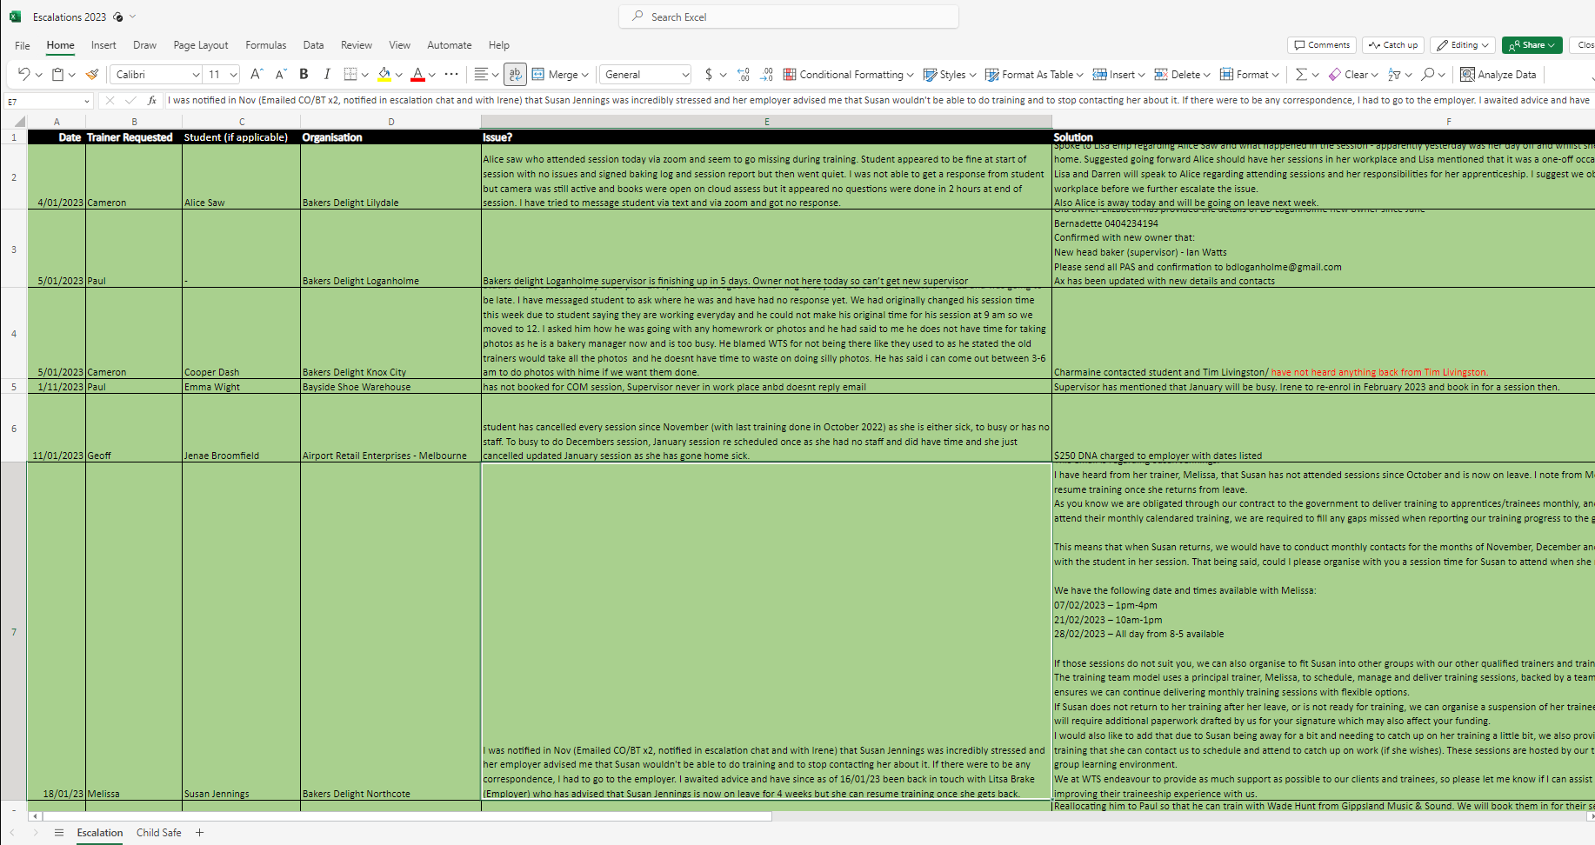

Child Safe Register

